**Guidelines before submitting CICD Request**

**Section 1.0: -New Request Submission:**

1. Below is the link to get to the JIRA page to submit new CICD request

<https://mcafeejira.atlassian.net/servicedesk/customer/portal/14/group/50/create/135>

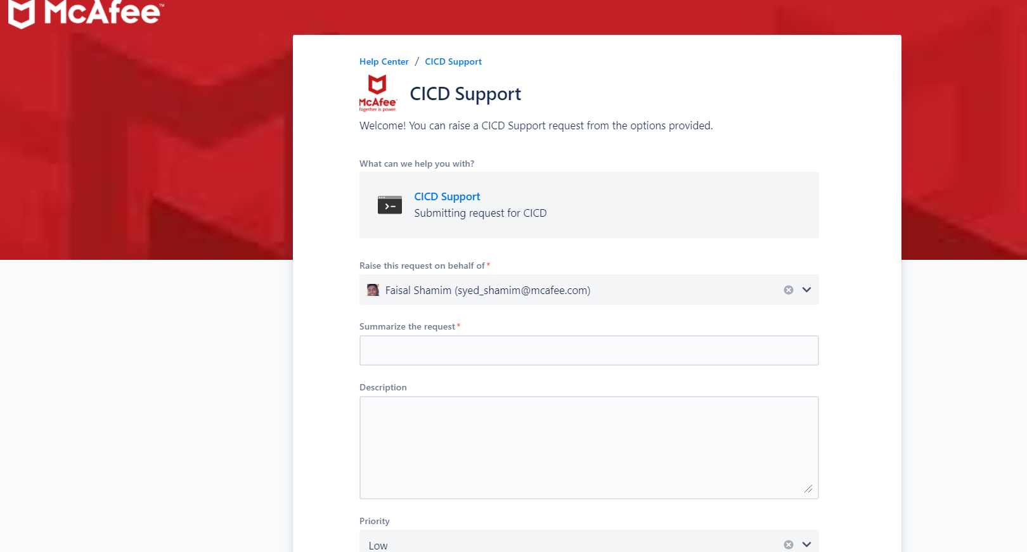

1. Fill the details required in the above fields
2. Click **“Send”** to submit the request
3. Once submitted, your request will be logged into JSD CICD project queu
4. 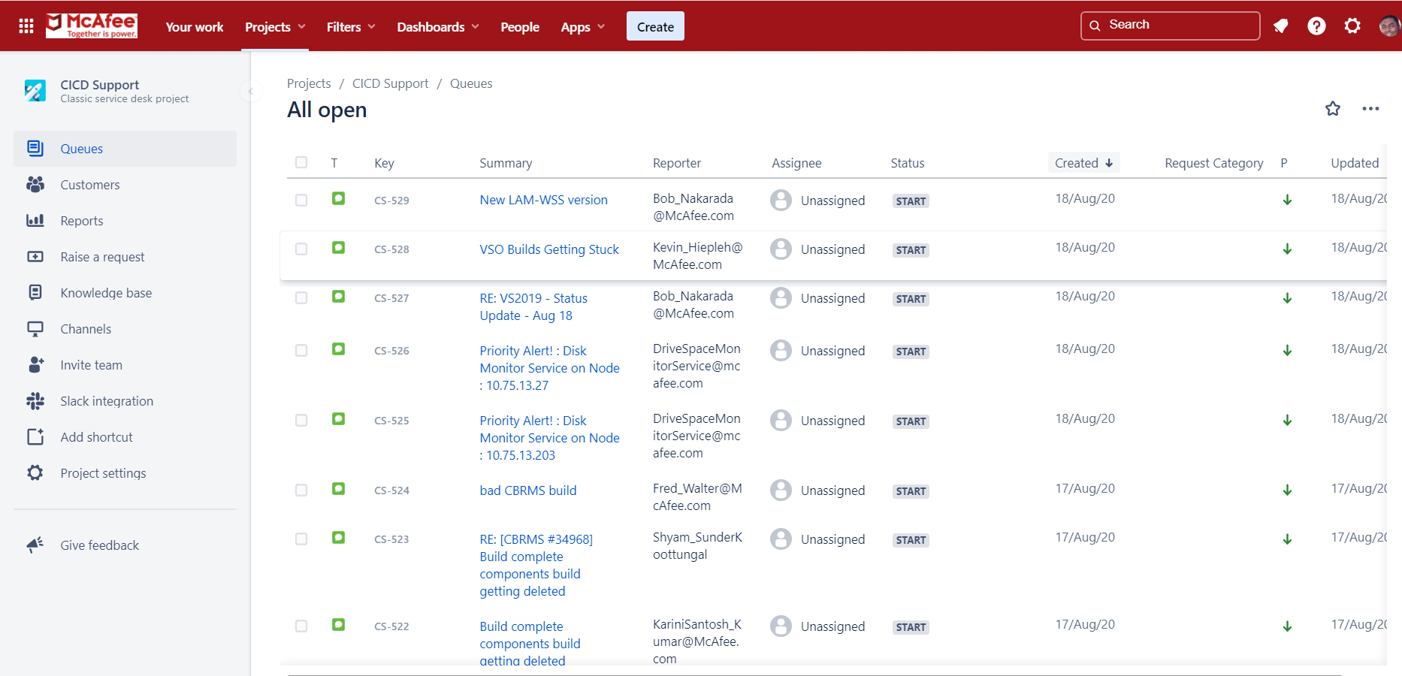
5. If it prompts to create JIRA account, please go ahead and set up new JIRA account with your McAfee email address as a onetime setup process

**Section 1.1: - How to receive and enable the notifications from JIRA: -**

1. Enable the email notification from JIRA if they are held up by **MB POSTMASTER EMAILS**
2. **Follow below steps to enable the notifications from MB Postmaster Email: -**
   1. Look for the emails from MB Postmaster with below content ([jira@mcafeejira.atlassian.net](mailto:jira@mcafeejira.atlassian.net))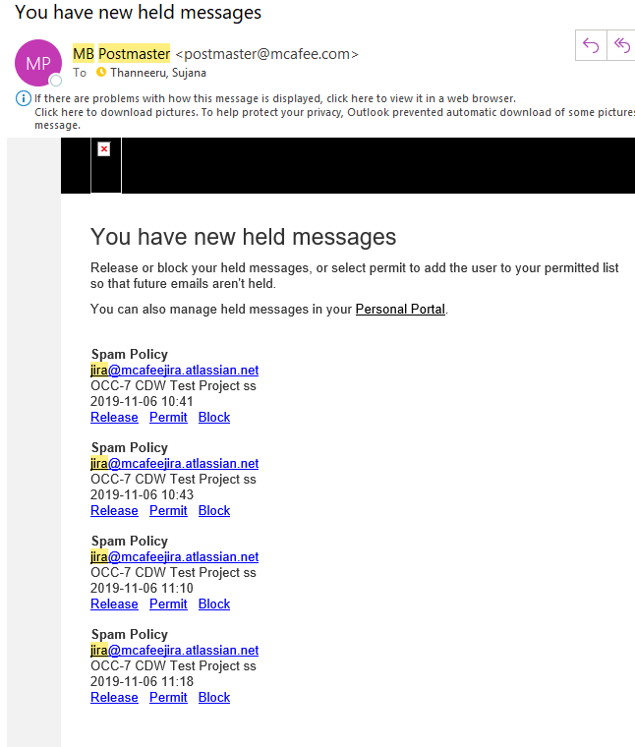
   2. Click **“Permit”** from the above emails to receive all the further updates made on your request submitted
3. **Follow below steps to enable the notifications from Mimecast portal:**
   1. Launch My Apps from the Intranet Portal

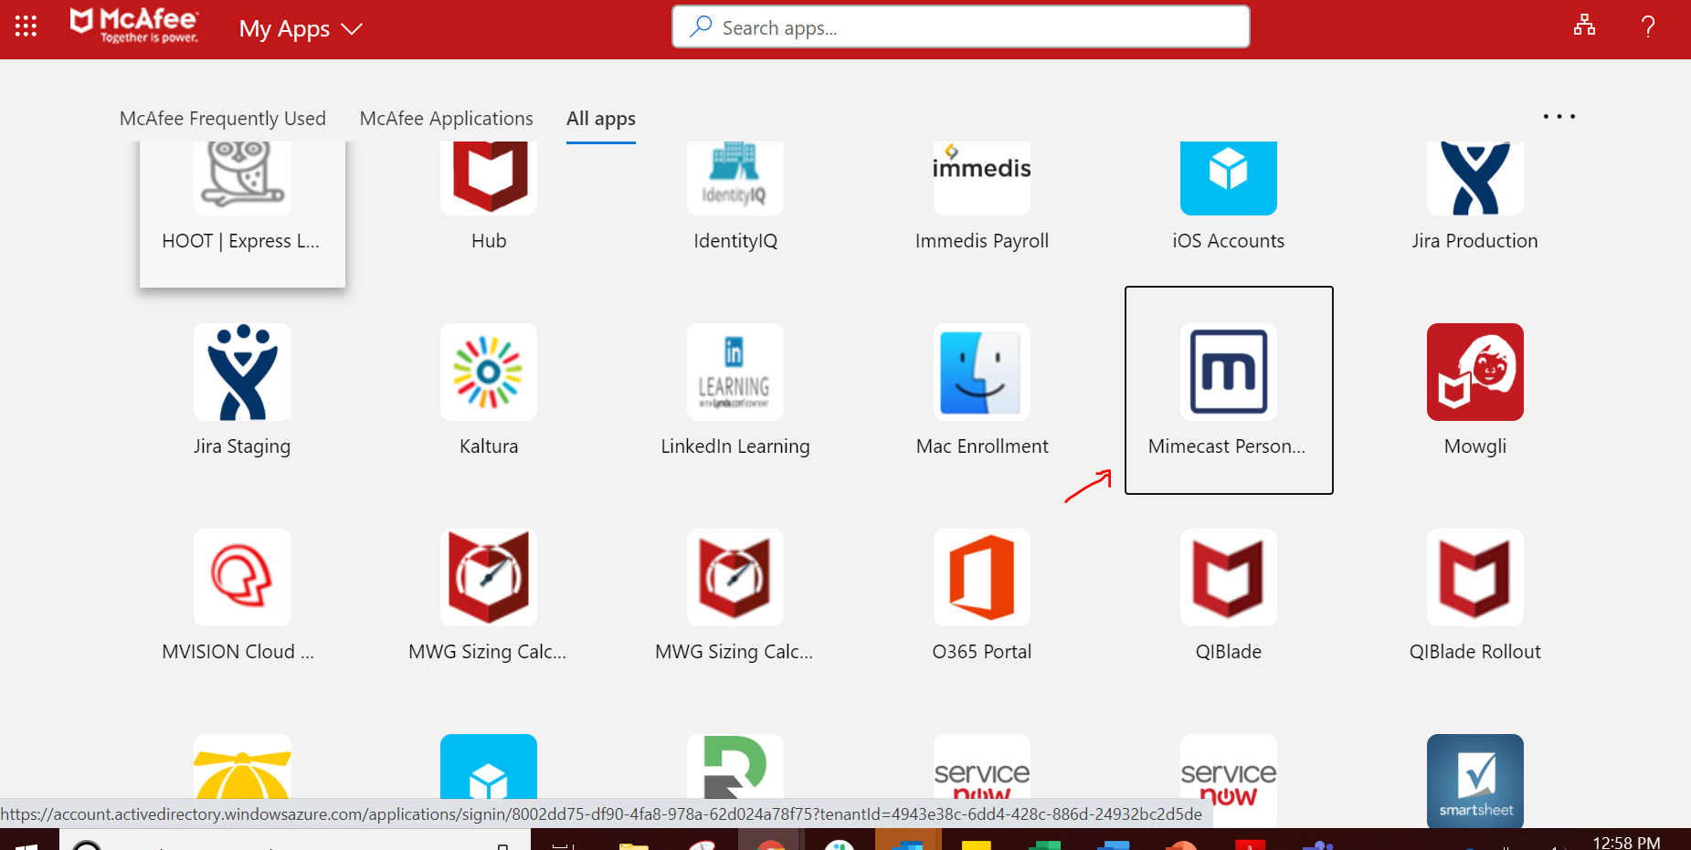

* 1. Look for any messages from[jira@mcafeejira.atlassian.net](mailto:jira@mcafeejira.atlassian.net) under below highlighted sections to select **“Release Message from Domain”** to receive all the updates from JIRA regrading your request.

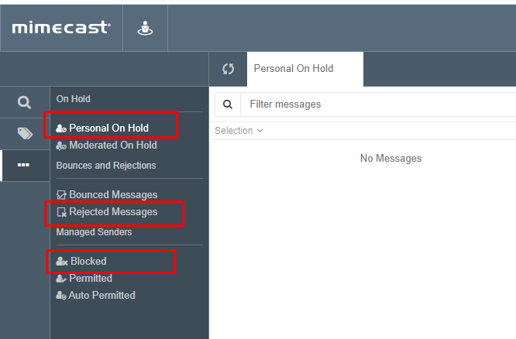

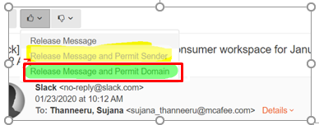

* 1. Now you are all set to receive the further updates and notifications from JIRA and never miss any notification pertaining to your request.